## **Problem 1.**

## **The CEO of the retail store is interested to view the time series of the revenue data for the year 2011 only. He would like to view granular data by looking into revenue for each month. The CEO is interested in viewing the seasonal trends and wants to dig deeper into why these trends occur. This analysis will be helpful for the CEO to forecast for the next year.**

I went ahead and created a line chart where the invoice date is on the x-axis and the revenue is on the y-axis. I calculated the revenue by multiplying Quantity by Unit Price. The data is granulated to each month, specifically for the year 2011.

Along with the line chart, I noticed that the revenue was at its peak in November and reached its lowest point in February. This insight could be valuable for understanding the seasonal variations or identifying patterns in the sales data.

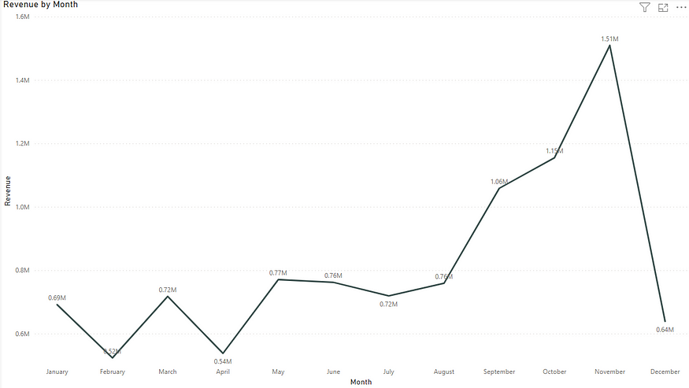

## **Problem 2.**

## **The CMO is interested in viewing the top 10 countries which are generating the highest revenue. Additionally, the CMO is also interested in viewing the quantity sold along with the revenue generated. The CMO does not want to have the United Kingdom in this visual.**

I tackled this question by whipping up a side-by-side bar chart. I made sure to include two bars for each country, showcasing both revenue and quantity for every region. To keep things neat, I slapped on a filter to spotlight only the top 10 countries raking in the most revenue. Oh, and the United Kingdom? I gave it the boot from the visual.

The Netherlands is bossing it — they’re making the most money and selling the most stuff, when we have excluded united kingdom from the chart.

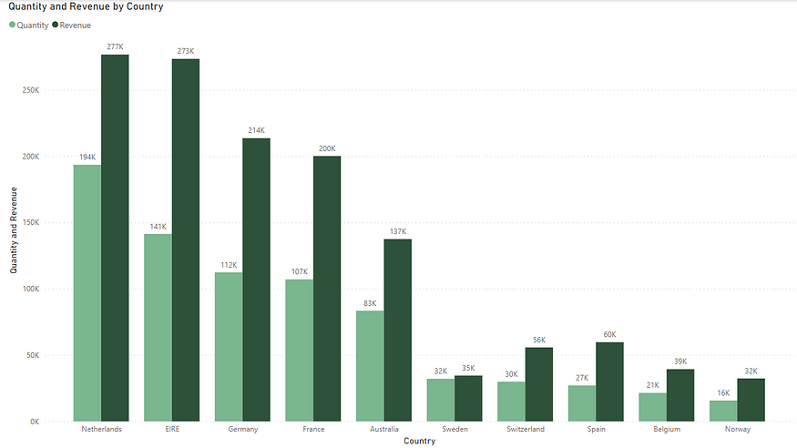

## **Problem 3.**

## **The CMO of the online retail store wants to view the information on the top 10 customers by revenue. He is interested in a visual that shows the greatest revenue generating customer at the start and gradually declines to the lower revenue generating customers. The CMO wants to target the higher revenue generating customers and ensure that they remain satisfied with their products.**

I tackled it by creating a column chart, specifically a vertical bar chart. Each bar vividly represents the revenue generated by the customers. To maintain clarity, I added a filter to showcase only the top 10 customers, identified by their unique “CustomerID.” Any customers lacking IDs gracefully bowed out of the visual. For the grand finale, I sorted the customers in a descending order, ensuring the stars of the revenue show took the spotlight.

Digging into the chart, the shining star of revenue contribution is none other than Customer ID 14646. This customer takes the crown for contributing the most to the revenue spectacle. Quite the top performer!

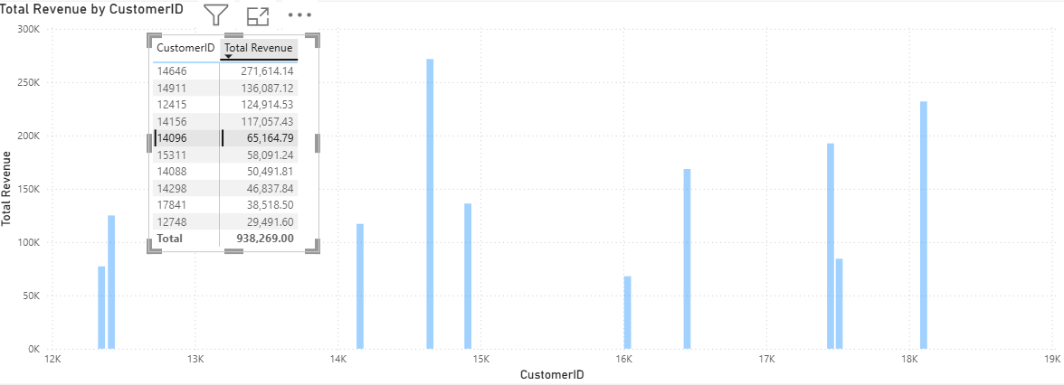

## **Problem 4.**

## **The CEO is looking to gain insights on the demand for their products. He wants to look at all countries and see which regions have the greatest demand for their products. Once the CEO gets an idea of the regions that have high demand, he will initiate an expansion strategy which will allow the company to target these areas and generate more business from these regions. He wants to view the entire data on a single view without the need to scroll or hover over the data points to identify the demand. There is no need to show data for the United Kingdom as the CEO is more interested in viewing the countries that have expansion opportunities.**

I created a map chart to provide the CEO with a comprehensive view of our global sales. The chart highlights each country, displaying either the total units sold or the country’s name. I took the initiative to filter out the United Kingdom from the data, ensuring a more focused visual representation. The aim is to make the name of each country or the total units sold easily visible for a quick and insightful overview.

